**DAILY ONLINE ACTIVITIES SUMMARY**

|  |  |  |  |  |  |  |  |  |
| --- | --- | --- | --- | --- | --- | --- | --- | --- |
| **Date:** | **01/07/2020** | | | | | **Name:** | **POOJA D S** | |
| **Sem & Sec** | **IV sem & B section** | | | | | **USN:** | **4AL18CS056** | |
| **Online Test Summary** | | | | | | | | |
| **Subject** | | **-** | | | | | | |
| **Max. Marks** | | **30** | | **Score** | | | **-** | |
| **Certification Course Summary** | | | | | | | | |
| **Course** | **Information to Programming** | | | | | | | |
| **Certificate Provider** | | | **Great learning academy** | | **Duration** | | | **5.5hours** |
| **Coding Challenges** | | | | | | | | |
| **Problem Statement1:** Given two lists, sort the values of one list using the second list | | | | | | | | |
| **Status: Executed** | | | | | | | | |
| **Uploaded the report in Github** | | | | | **YES** | | | |
| **If yes Repository name** | | | | | <https://github.com/dspooja/Java-coding/blob/master/july%201st%20list_sort.py> | | | |
| **Uploaded the report in slack** | | | | | **YES** | | | |

Online Test Summary: No internals conducted today.

Online Certification Course Summary: In today’s session I have about the Basic Problem in Python, Function in Python, Intro to Object Oriented Programming in Python, Creating the first class in Python Adding Parameters to a Class Method.

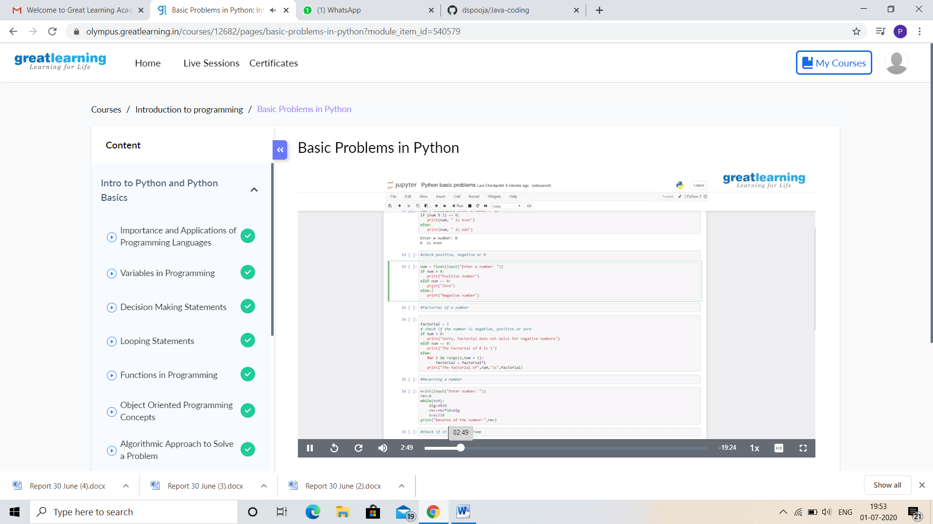

This is the snapshot of today’s session.

Online Coding Summary: **Today I had received programs from Mr. Vasudev Shahapur. I have also uploaded them to my Github repository.**

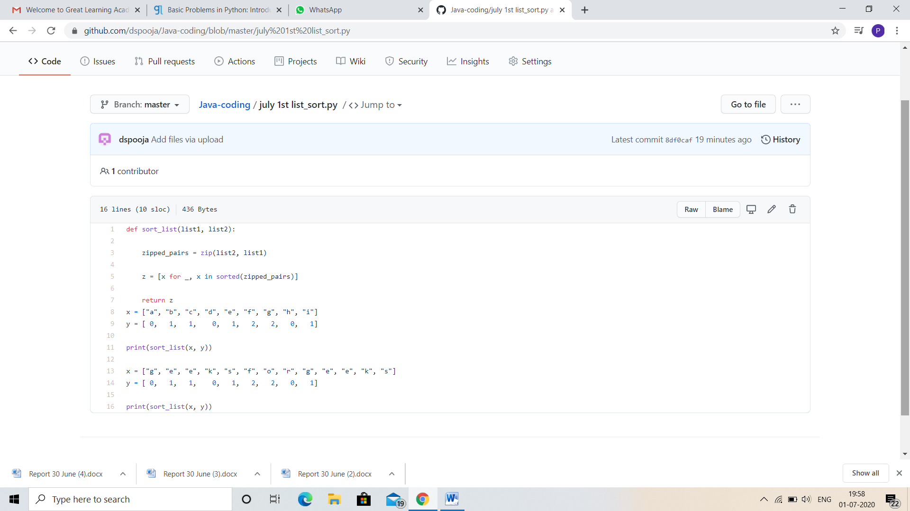

**This is the snap shot of my Github repository** were I have uploaded the code. File name is list_sort.py